**Starplify Bugs Report**

**In Sign Up**

* *Verify Email overlapping with Email*
* *Also OTP not coming on time, least first time it refused to come*

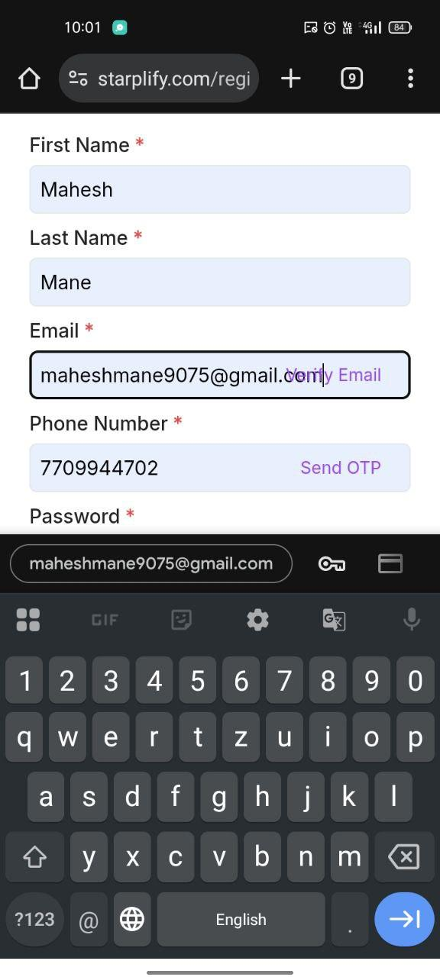

* *UI at terms and conditions*

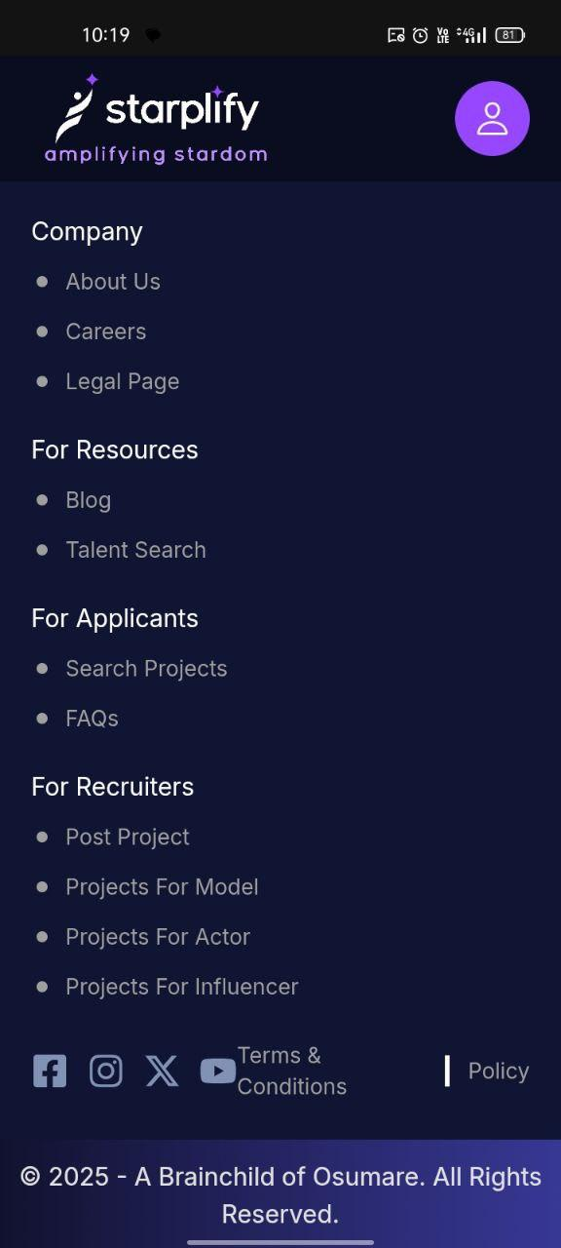

**After Sign up, In adding Information**

* ***Coming back problem***
* *In Language You know*

*We can Select at Max 3 languages then continue to the next section but when we come back to that page again after filling info and even without changing anything it is saying to add language(even we have reach the max limit)*

* *Also other issue is that when we click it's drop-down, it is opening keyword, which causing the options to get hidden inside the keyboard.*

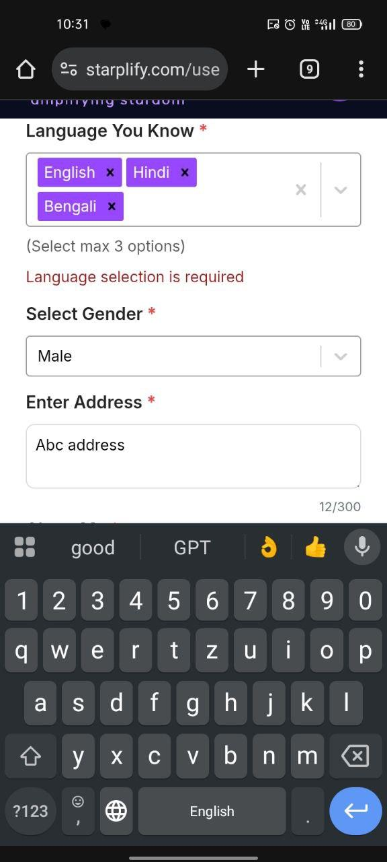

* *Same goes for about me section*

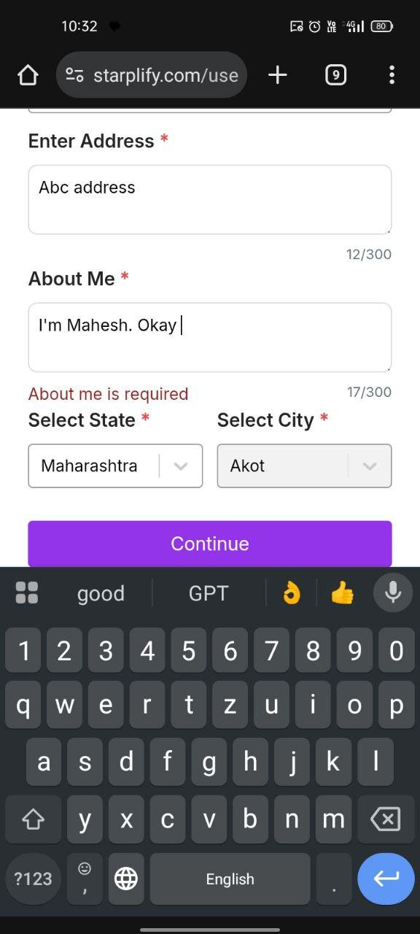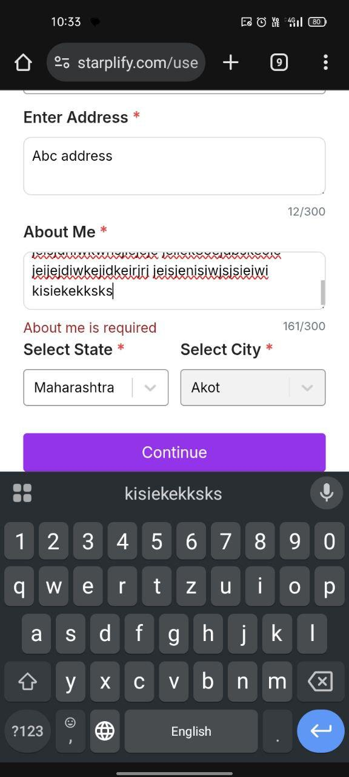

* *And same for How Often Do You Post*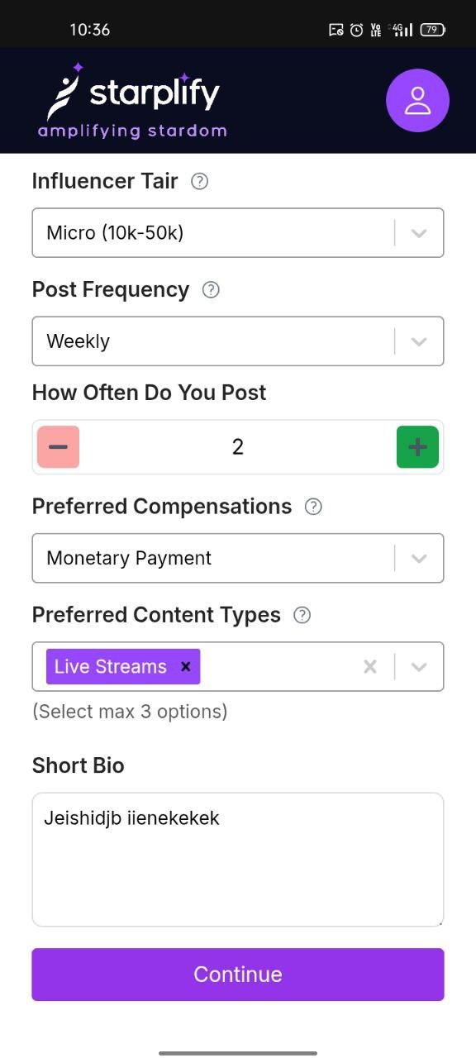

***In Add Your Experience***

* *It should have option to add first then add more I find it odd*
* *Coming back issue too*

*In that section, when I add all info for 1st experience, then wanted add 2nd too, but then removed*

*But when I came back it is not showing the image there, also it is showing 2nd form too as empty*

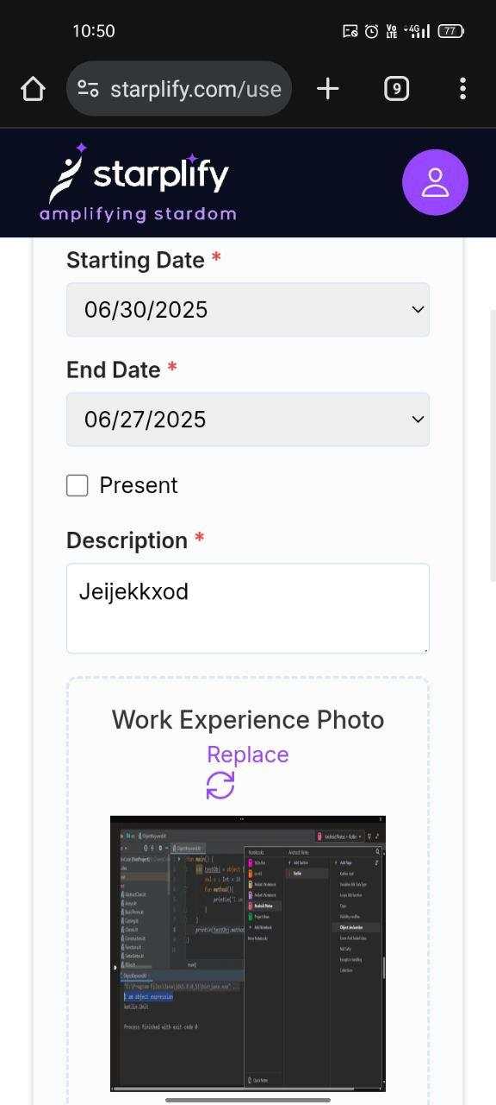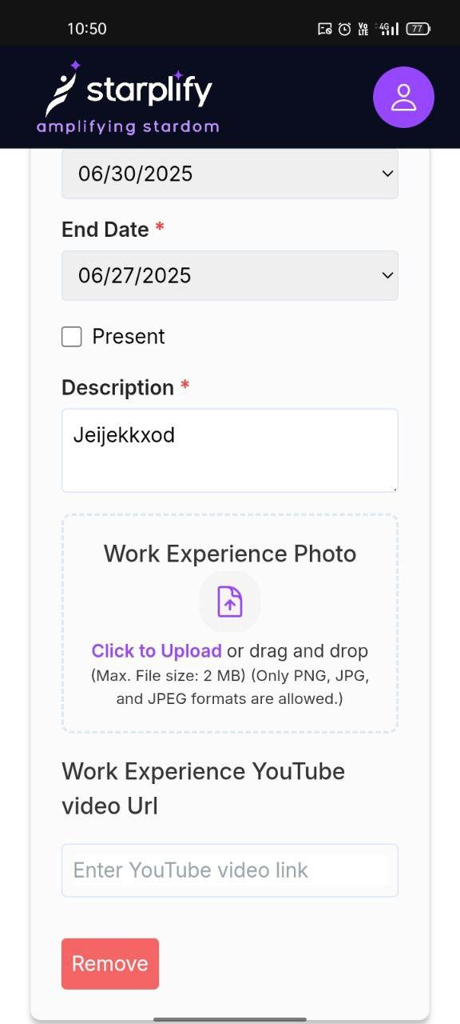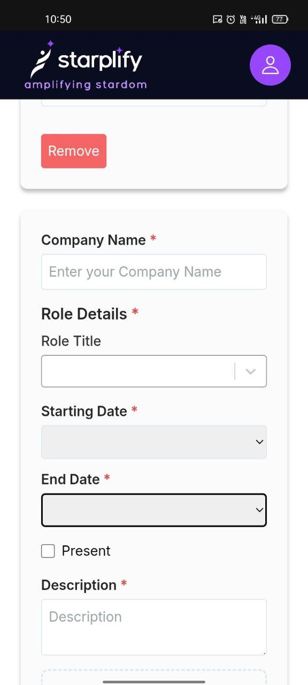

* *Look at date section, invalid*

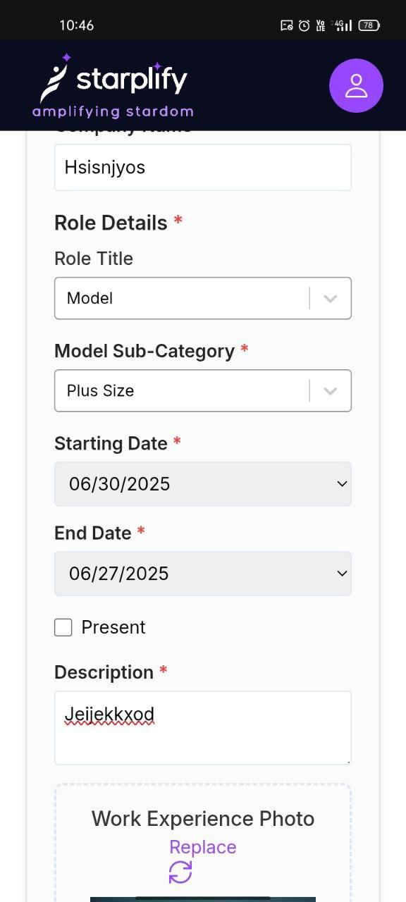

* *Coming back issue in Tell us your project section with selection*

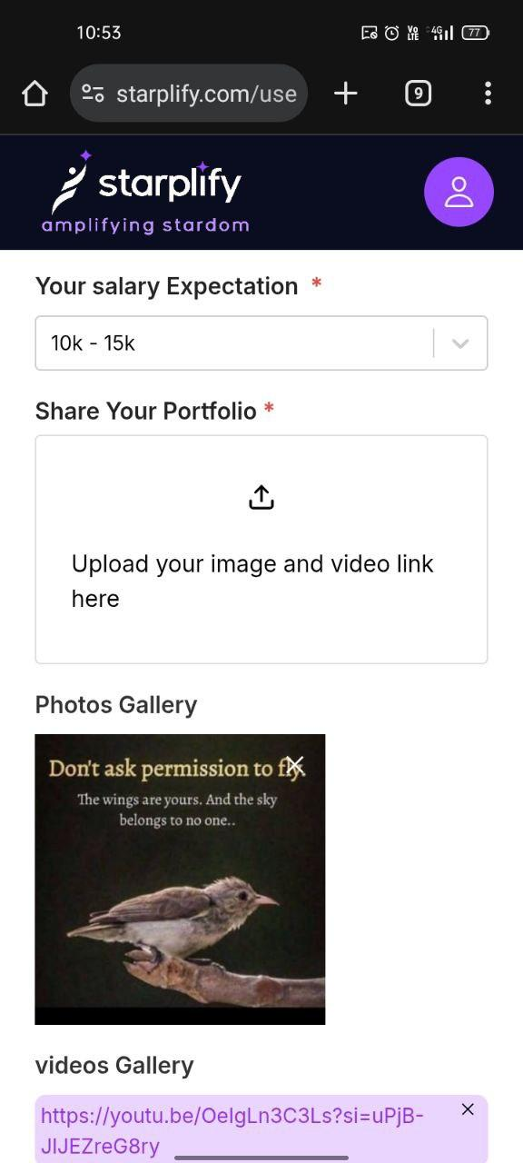

***In Link your Social media section***

* *For IG it is not taking the actual profile URL*

*Actual - https://www.instagram.com/animetm_talks?igsh=MTJoNXUxcnNibm1kdg==*

*Valid -*

*https://www.instagram.com/animetm_talks*

*For YT :*

*it do not take channel URL any how*

*But Video URL*

* *Also Range goes when coming back*

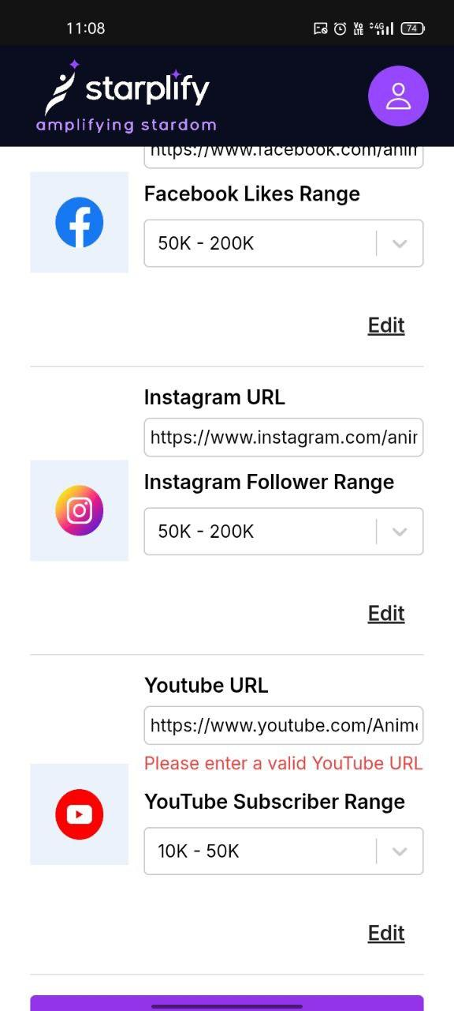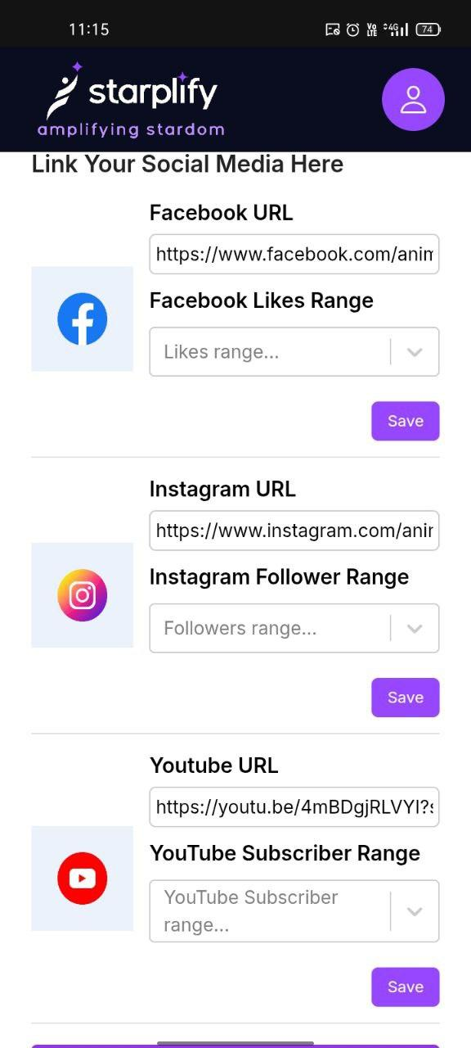

* *In Government Document Section*

*PDF preview section is not showing the PDF*

*There is also coming back problem*

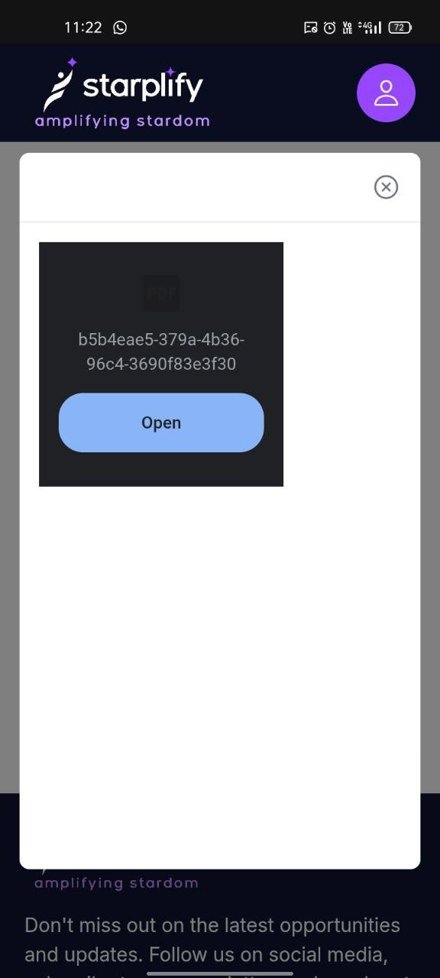

***After Information filling is done, we are redirected to the dashboard***

* *There are some job post, when we check perticular post and then press back it is going to search project section, not where we came from (Dashboard)*
* *The Job Post UI looks inconsistent*

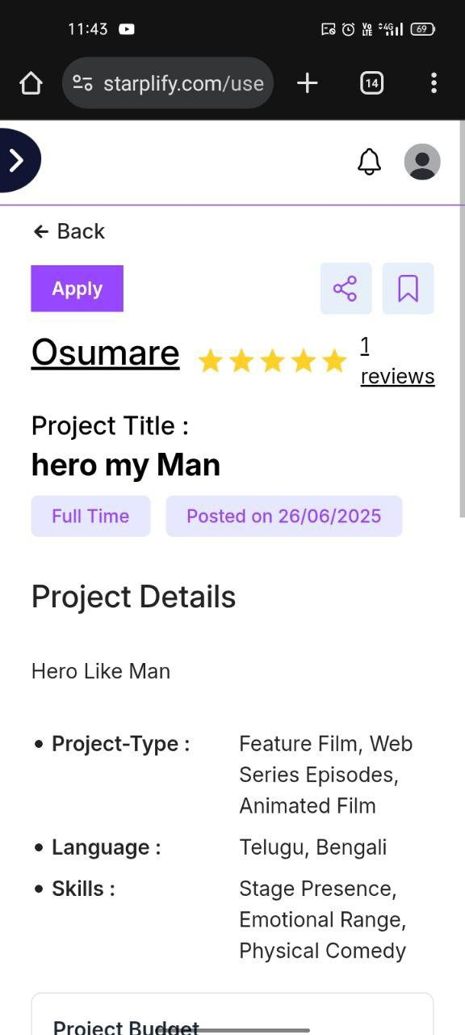

* *Also if side bar/navigation bar could toggle it could be good*
* *Also Job applying screen can be better*

*Button at corner doesn't seems better*

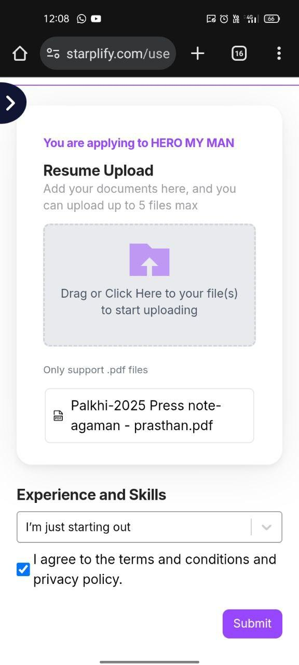

***In search Projects Section***

* *We could give suggestions when we are searching*

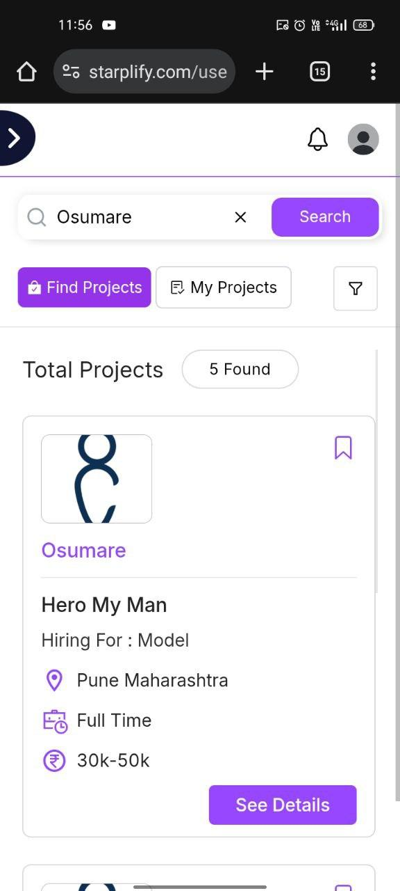

* *Also when Job poster haven't add the salary, it is showing only icon*

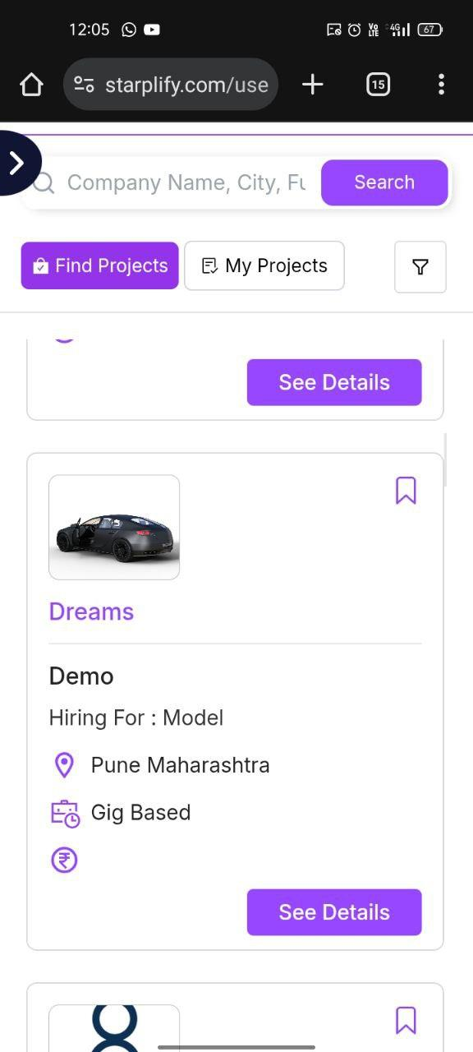

* *In My Projects section Inconsistent UI items display*

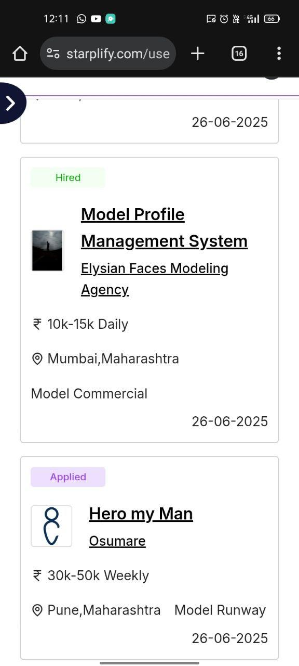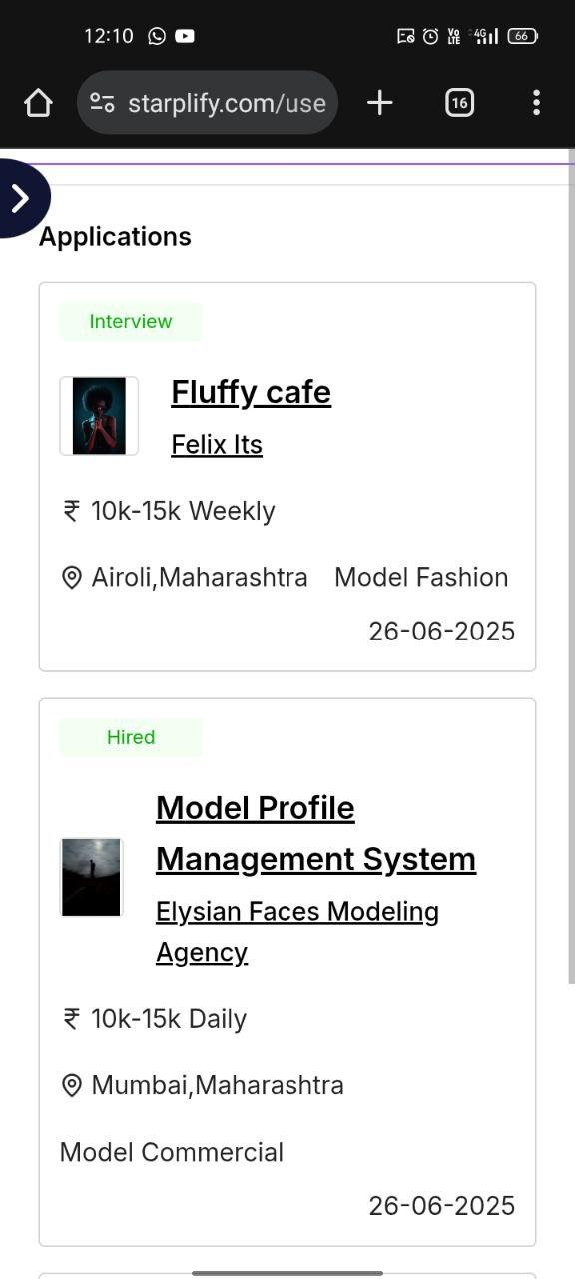

* *When we enter the long name it is getting overlap with x sign*
* *Also showing all 28 posts in 1 go might be too long, maybe we can add pagination, it feels overwhelming on small devices,we also have that in UI too*

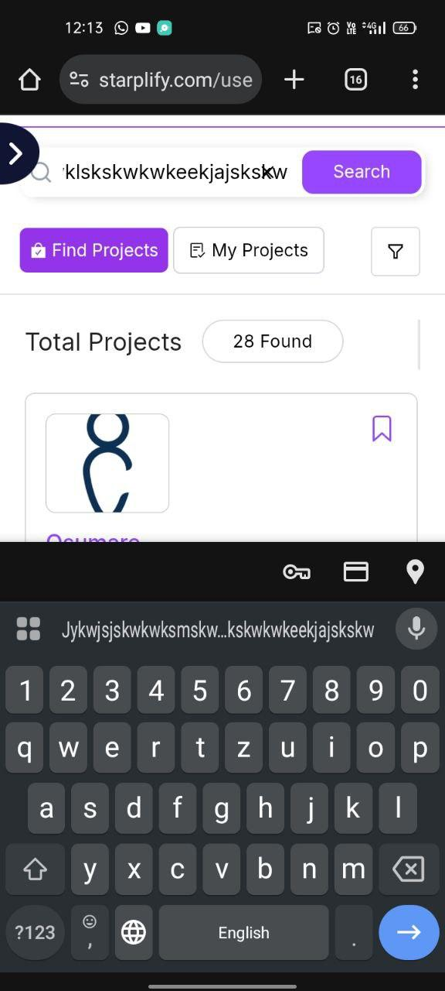

***In a filter***

* *When we select the influencer, it adds some fields, it have some extra check boxes in a Engagement level and Industry section*

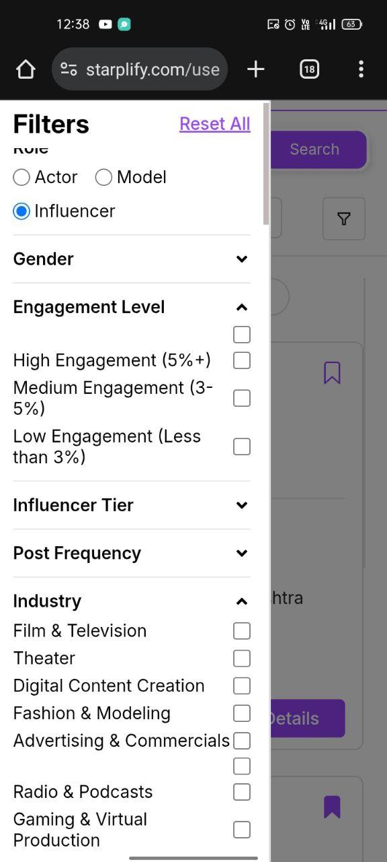

***In profile section***

*In Experience*

* *If I add info with img and submit and later I want to delete image, what I can do delete the delete post or replace image, can't deselect the image*

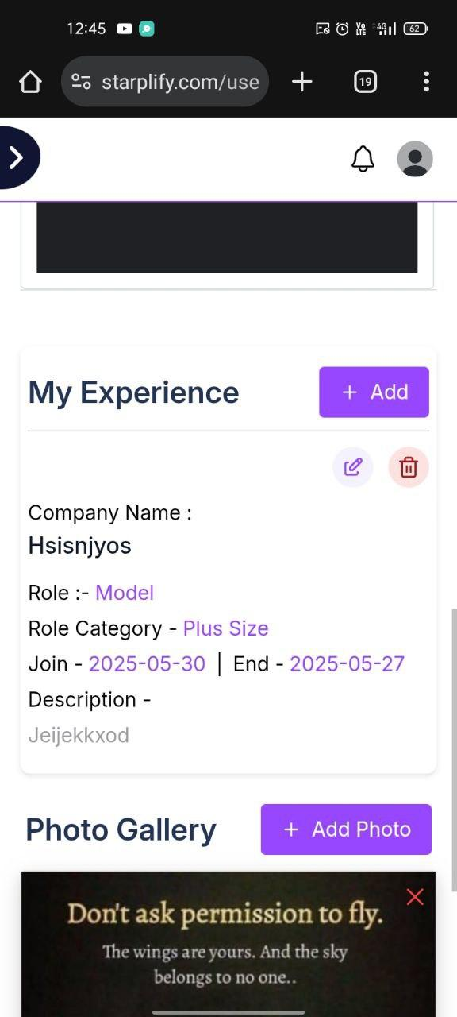

***In profile - Video Gallery***

* *If I want remove existing URL or new one*

*It is not happening, it is just redirecting to the that already existing URL*

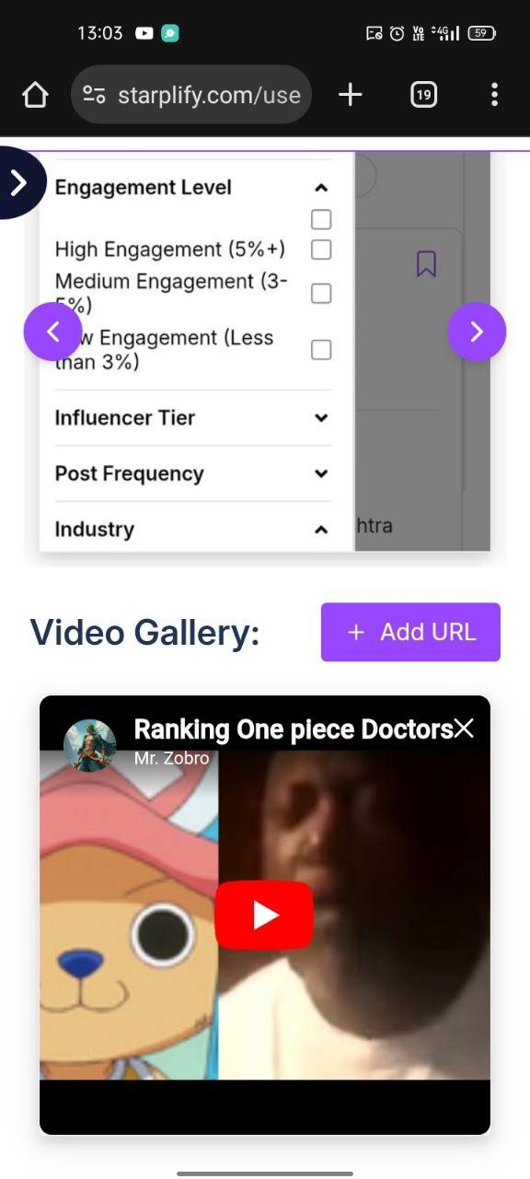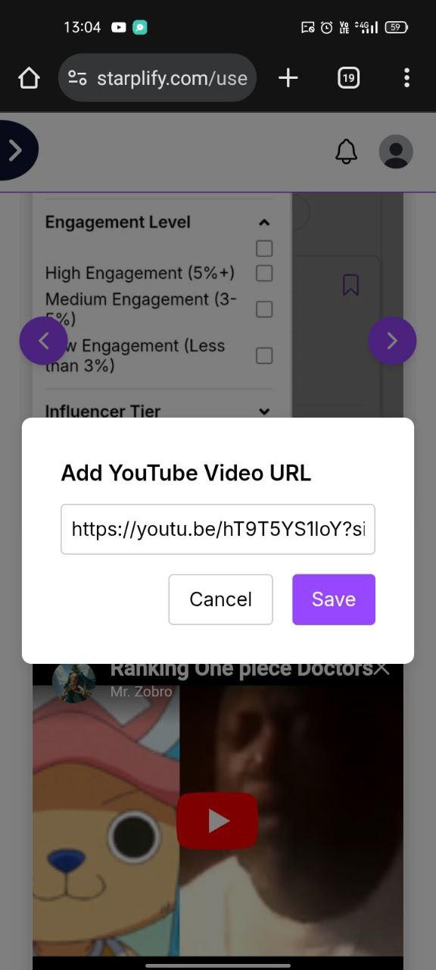

***In profile section***

***Personal Info***

* *I edited Maharashtra & Pune(State & City) —> Manipur & Pune (Which shouldn't save the record like that)*
* *Also I can't able to change the qualification at 1st*

*It was set to the Mcs, when i change and update it*

*It still show's only Mcs*

* *Also there is horizontal scroll bar, thought there is no drop down( i mean it is hiding Scroll Bar)*

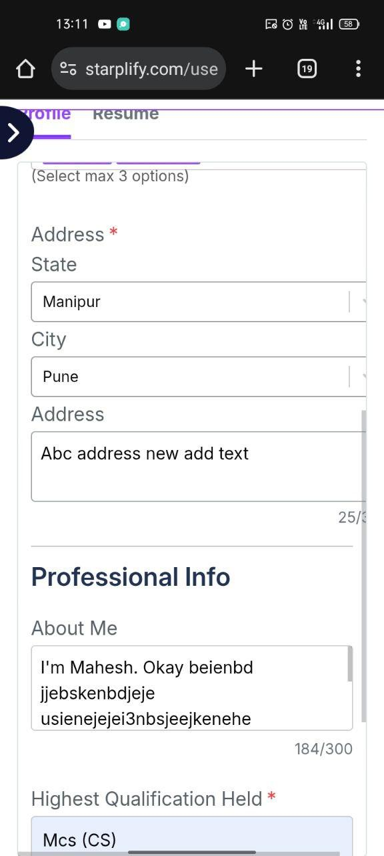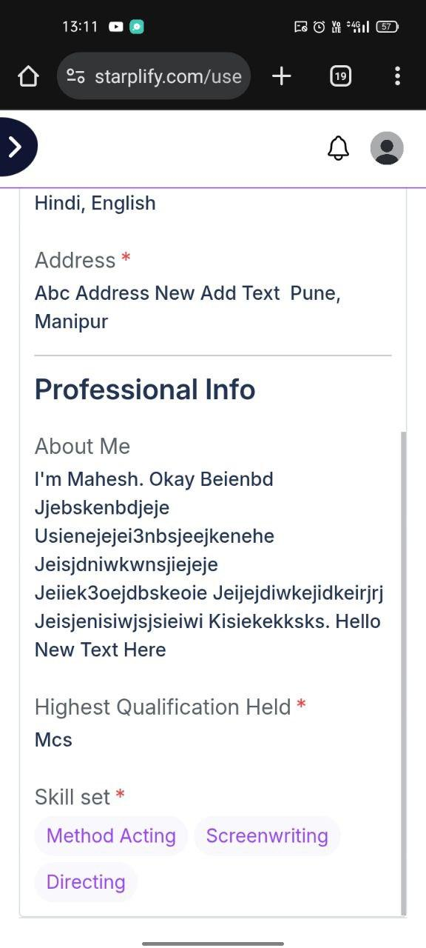

***Profile Resume (Update)***

* *Plz mention the upload file format and size*

***In analytics section***

* *Total time spent do not update even I used from 10 to 2*
* *Also there is option to check the Job which have hired u*

*But it is redirecting to error page*

*Least show not found*

*It should a show that job page or company*

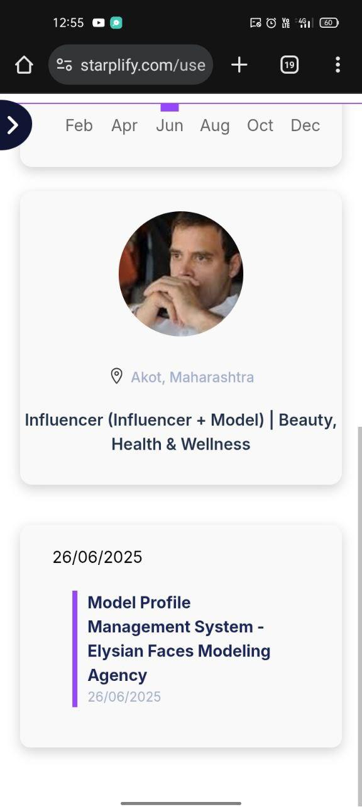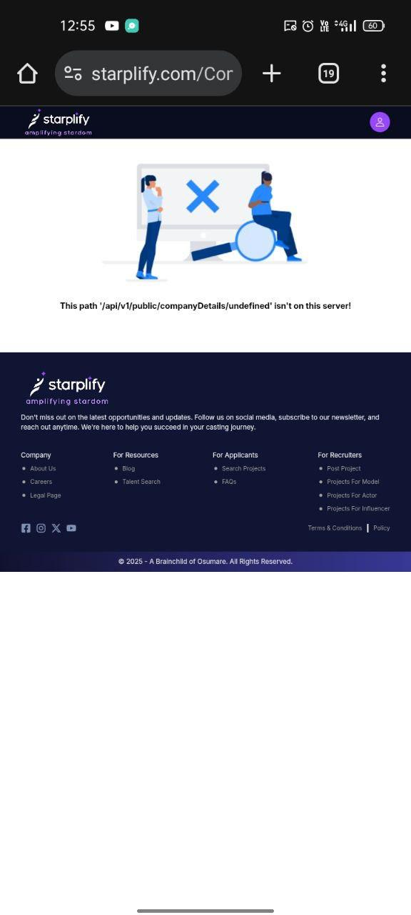

*Also* ***in Message section*** *it is not showing the user pfp there*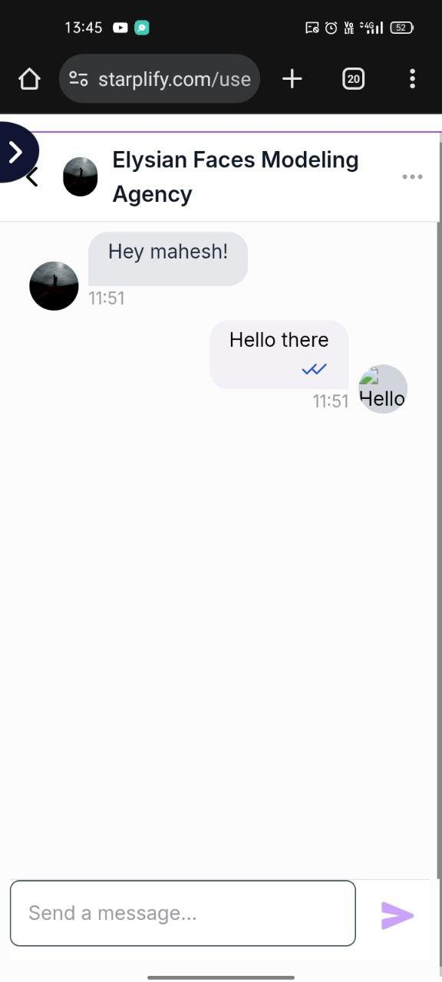

* *Also when I'm in search project section and i receive new notification it is not showing*

*When switch to dashboard or notification icon it is showing only*

***…Thank You…***